### **The Deadly Divide – A Global View of Homicide Victims and Suspects**

submitted by: divija cherukuri

tools used: powerbi, excel

dataset: data_cts_intentional_homicide

source: [Here](https://dataunodc.un.org/victims-intentional-homicide-table)

**Objective:**

This project aims to explore and visualize global trends in intentional homicides, focusing on the gender divide between male and female victims, and contrasting this with the demographics of suspected offenders. The goal is to reveal disparities in victimization and criminal accountability through time, geography, and sex.

**Dataset Details:**

| **Feature** | **Suspects Sheet** | **Victims Sheet** |
| --- | --- | --- |
| **Focus** | People arrested or suspected for intentional homicide | People killed by intentional homicide |
| **Geographic Granularity** | Country-level (e.g., Armenia, Colombia) | Region-level (e.g., Sub-Saharan Africa, Latin America) |
| **Time Coverage** | 2000–2024 (varies by country) | 2000–2024 (varies by region) |
| **Gender Breakdown** | Yes (Male, Female, Total) | Yes (Male, Female, Total) |
| **Age Information** | Yes (e.g., Total or by age group) | No |
| **Region/Subregion Info** | Yes (Continent and Sub-region) | Yes (Region and geo field) |
| **Key Dimensions** | Citizenship, location, mechanism, perpetrator relation, etc. | Victim counts (series: Number of victims) |
| **Measurement Type** | Count of suspects/arrests (VALUE) | Count of victims (value) |
| **Indicator Column** | Persons arrested/suspected for intentional homicide | Victims of intentional homicide |
| **Source** | Mostly CTS (UN Crime Trends Survey) | Mostly UNODC estimate |
| **Data Columns** (example) | Country, Region, Sex, Dimension, Year, VALUE, Source | Region, geo, Year, Sex, value, obs_status, source |

**Pages:**

1. Victims:

This dashboard contains the main analysis and visualization the taken dataset which has “Victims” details. The Deadly Divide: Global POV of Male and Female Homicide Victims talks about various victims from various regions. Analysis of victims of homicide over time and grouped by year and gender.

We also find the button “Whos’s Killing?” it is so eye grabbing but what does it do? So this button is responsible to showing us the next slide which is the analysis of victims over time, over region and the categories of suspects based on their citizenship.

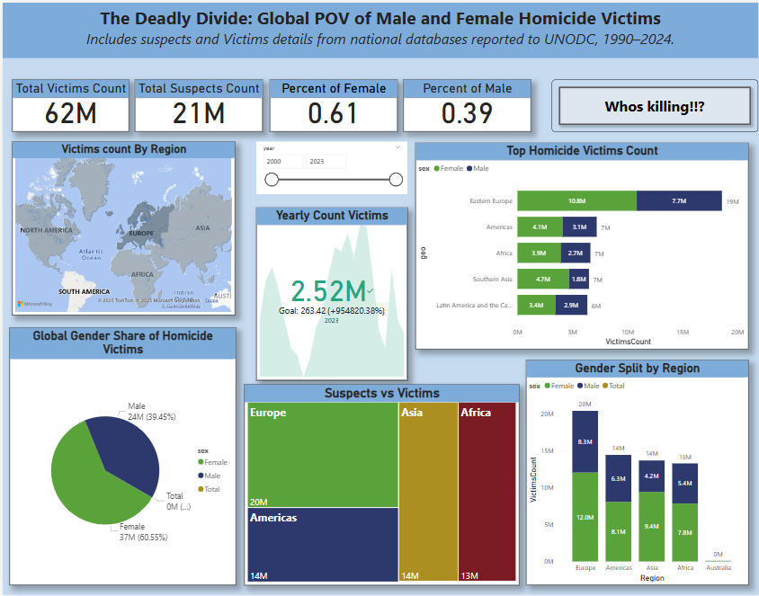

______________________________________________________________________________

1. Homicide Suspects:

This particular Dashboard talks about the suspects of crimes details. Here we see words like % of suspects, average suspects, yearly average of the suspects in respect to the regions. We can see some of mail analysis include using the slicer year, region, sex and Dimension. The dimension keyword tells us what the suspects status is in that particular crime when he/she was convicted

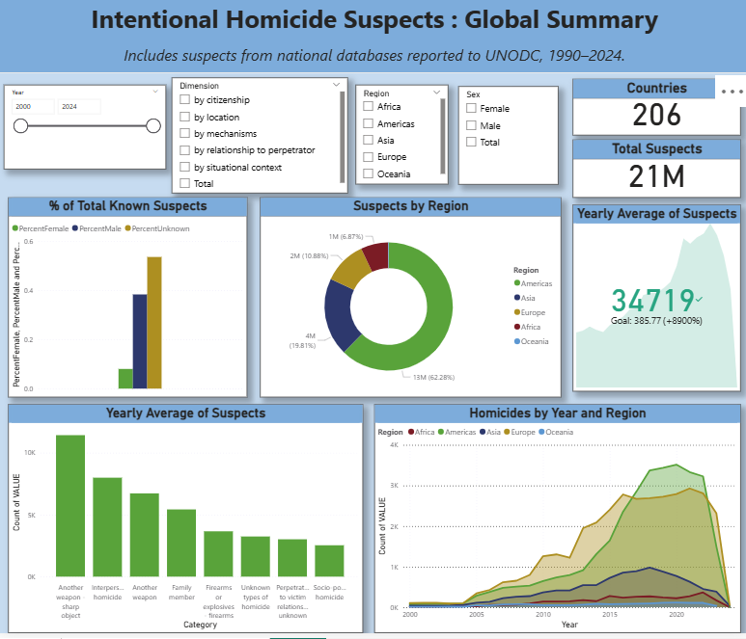

**Dashboard Highlights:**

1. Total Victims vs. Total Suspects Count (Global scale)
2. Gender Breakdown: Proportion of male vs. female victims globally
3. Victim Count by Region: Interactive world map showcasing geographic distribution
4. Suspects vs Victims by Region: Treemap comparing how different regions report suspects versus victims
5. Highest Victims Over Time: Stacked bar chart showing gender-wise trends over years
6. Yearly Victim Count Trend: Area chart highlighting peaks, trends, and goals
7. Page Navigation Button: Enables multi-page exploration (e.g., for gender breakdown)

**Insights:**

* Female victims often constitute a smaller portion of suspects, despite high victimization in certain regions.
* Gender imbalance is visible over time: female homicide rates stay steady, while male victimization fluctuates more sharply.
* Some regions report high victim counts but few suspects, indicating possible data underreporting or systemic issues in investigation processes

**Steps followed:**

* Data Preparation: Cleaned and joined datasets by year, region, and gender.
* Calculated Measures: Total counts, gender percentages, year-wise trends.
* Visualizations: KPI Cards, Map, Treemaps, Bar/Area Charts, Page Navigation
* Interactive UX: User-friendly navigation and tooltips for accessibility

**Outcome:**

The final dashboard presents a clear, interactive, and gender-sensitive view of global homicide data, revealing the “deadly divide” between female and male victims and highlighting gaps in suspect reporting. It enables data-driven conversations about gender, violence, and justice in global contexts.